## Front End Engineering-II

Project Report

Semester-IV (Batch-2022)

Title of the Project: Template(29)



**Supervised By: Submitted By:**

Raveesh Samkaria Name:Suhavi Jindal

Roll no: 2210990867

Group: G-13

**Department of Computer Science and Engineering**

## Chitkara University Institute of Engineering & Technology,

## Chitkara University, Punjab

**CONTENTS:**

|  |  |  |
| --- | --- | --- |
| **S.NO** | **CONTENT** | **PAGE.NO** |
| **1** | **Abstract** | **1-2** |
| **2** | **Introduction** | **2-5** |
| **3** | **Problem Definition and Requirements** | **5-6** |
| **4** | **Proposed design** | **7-9** |
| **5** | **HTML code** | **10-14** |
| **6** | **CSS code** | **15-22** |
| **7** | **Result** | **23-35** |

**Abstract:**

HTML (Hypertext Markup Language) and CSS (Cascading Style Sheets) form the backbone of web development.

**HTML (Hypertext Markup Language)** is the standard markup language for creating web pages and web applications.

**Let’s break down the components:**

**<!DOCTYPE>:** Defines the document type or instructs the browser about the HTML version.

**<html>:** Informs the browser that it’s an HTML document. The content between the <html> tags describes the web document.

**<head>:** Contains metadata (information about the document) and should be the first element inside <html>.

**<title>**: Adds the title of the HTML page (appears at the top of the browser window).

**<body>:** Contains the main content visible to the end user.

**CSS (Cascading Style Sheets)** is a fundamental technology used in web development. Let’s dive into what CSS entails:

**Definition**:

**CSS** is a **style sheet language** that specifies how HTML elements should be **presented and styled** on various media, including screens, paper, and other devices.

It works alongside HTML and JavaScript to create visually appealing and well-organized web pages.

**Key Points**:

**Presentation and Styling**: CSS defines the visual appearance of web content. It controls aspects such as fonts, colors, spacing, layout, and positioning.

**Cascading**: The term “cascading” refers to the order in which styles are applied. Multiple styles can be combined, and the most specific rule takes precedence.

**Stylesheets**: CSS rules are typically stored in external .css files. These files contain style definitions that can be reused across multiple web pages.

**Introduction:**

**Personal Portfolio Website**:

Showcase your uniqueness by designing a well-crafted portfolio website. Highlight your abilities, accomplishments, and past projects.

Include sections like an “About Me” page, portfolio gallery, and contact information.

**Responsive Landing Page**:

Create a landing page that adapts seamlessly to various screen sizes. Prioritize user experience across devices.

Use CSS media queries to ensure responsiveness.

**Blog or Article Layout**:

Design a clean and readable layout for blog posts or articles.

Implement features like headings, paragraphs, images, and a comment section.

**Product Showcase**:

Build a visually appealing product showcase page.

Include product images, descriptions, and pricing details.

**Online Resume/CV**:

Develop a professional online resume or CV.

Highlight your skills, work experience, education, and achievements.

**Social Media Profile Clone**:

Create a simplified version of a social media profile page (e.g., Twitter, Instagram)

Focus on styling user profiles, posts, and follower counts.

**Animated Search Button**:

Add animation effects to a search button.

Experiment with hover effects or transitions.

**Responsive Navbar**:

Create a navigation bar that collapses into a mobile-friendly menu on smaller screens.Use CSS flexbox or grid for layout.

**Background:**Provide context for the project, explaining why it is relevant and necessary.

**Objectives:**

Create an engaging and visually appealing web project that demonstrates your skills, creativity, and understanding of front-end development.

**Goals**:

**Showcase Your Skills**: Highlight your proficiency in HTML and CSS by implementing various features and layouts.

**Responsive Design**: Ensure your project looks great on different devices (desktop, tablet, and mobile).

**User Experience**: Prioritize readability, intuitive navigation, and user-friendly interactions.

**Unique Style**: Infuse your project with a distinctive visual style that aligns with your brand or concept.

**Learn and Experiment**: Use this project as a learning opportunity to explore new techniques and best practices.

**Significance:**

**Professional Branding and Visibility**:

A well-designed website or project showcases your brand identity and professionalism.

It serves as a digital business card, allowing potential clients, employers, or collaborators to learn about you and your work.

**First Impressions Matter**:

Your project’s design and usability create an immediate impression.

A visually appealing and functional project can captivate visitors and encourage them to explore further.

**Skill Demonstration**:

Creative projects demonstrate your technical skills in front-end development.

Employers and clients often evaluate candidates based on their portfolio projects.

**Learning and Growth**:

Building projects helps you learn and apply new concepts.

Experimenting with HTML, CSS, and even JavaScript fosters continuous improvement.

**Problem-Solving Abilities**:

Projects require problem-solving skills.

Overcoming design challenges, responsiveness issues, and browser compatibility demonstrates your adaptability.

**Potential Business Opportunities**:

Your project could evolve into a full-fledged business.

If it solves a real-world problem or meets a need, it might attract users and generate revenue.

**Networking and Collaboration**:

Sharing your project online (via social media, GitHub, or personal website) connects you with like-minded individuals.

Collaborations, feedback, and networking opportunities may arise.

**Inspiring Others**:

Your creative project can inspire fellow developers, designers, or entrepreneurs.

Sharing your process, challenges, and solutions encourages others to embark on their own projects.

**Boosting Confidence**:

Successfully completing a project boosts your confidence.

It validates your abilities and motivates you to take on more ambitious endeavors.

**Problem Definition and Requirements**

**Problem Statement:**Describe the specific problem or challenge addressed by the project.

**Software Requirements:**List the software tools, libraries, and technologies used.

****Text Editors / Integrated Development Environments (IDEs)**:**

**Visual Studio Code (VS Code)**: A popular free code editor with excellent HTML and CSS support.

**Browser Extensions**:

**Live Server**: Instantly reloads your HTML and CSS changes002

**CSS Viewer**: Inspect CSS properties on any webpage.

**Hardware Requirements:**Specify any hardware components required for the project.

**Web Browser**:

Install popular web browsers for testing your HTML and CSS:

**Google Chrome**

Choose a text editor or integrated development environment (IDE) for writing code:**Visual Studio Code (VS Code)**

**Proposed Design**

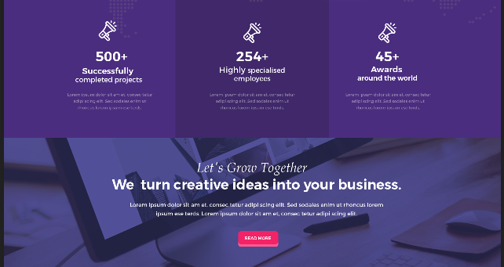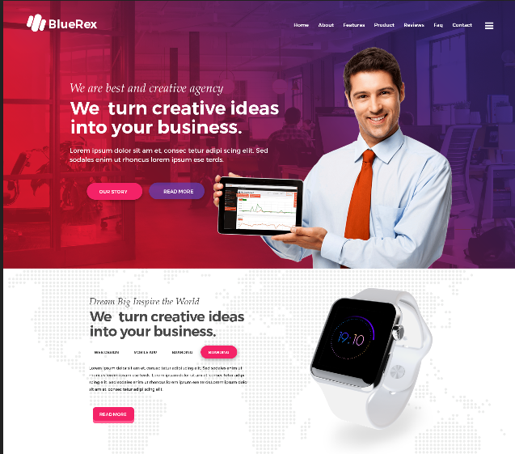

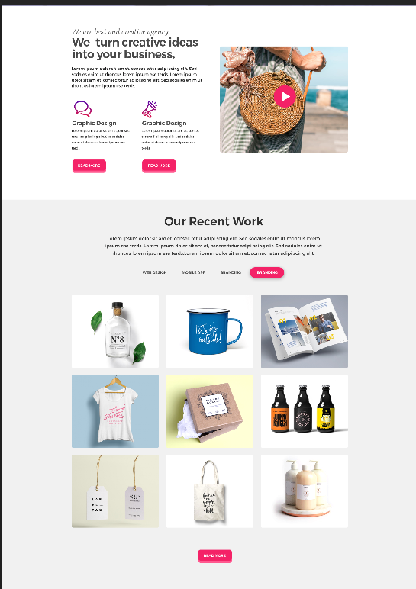

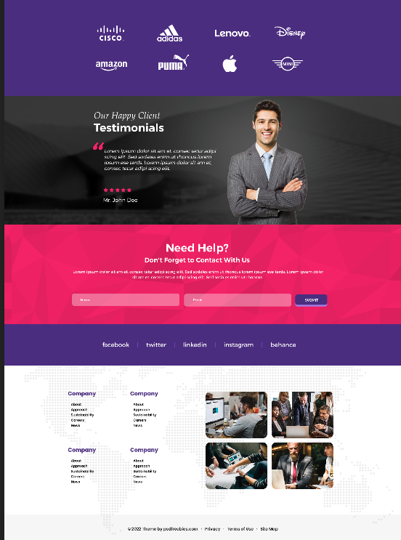

**SOURCE CODE:**

**HTML CODE:**

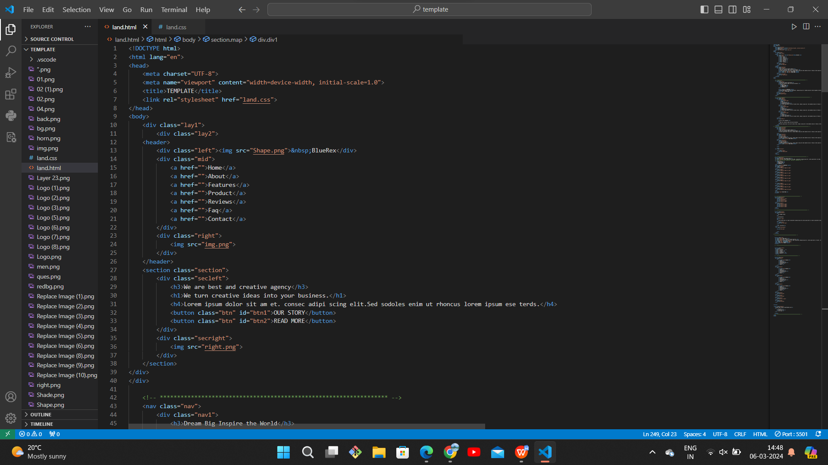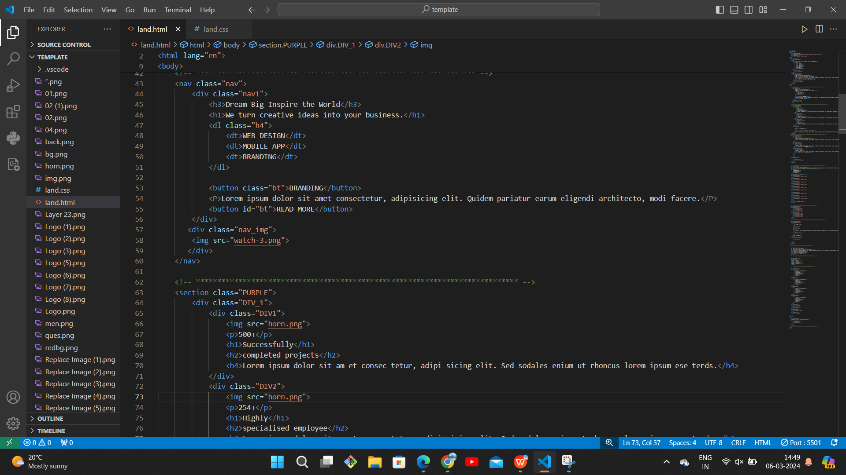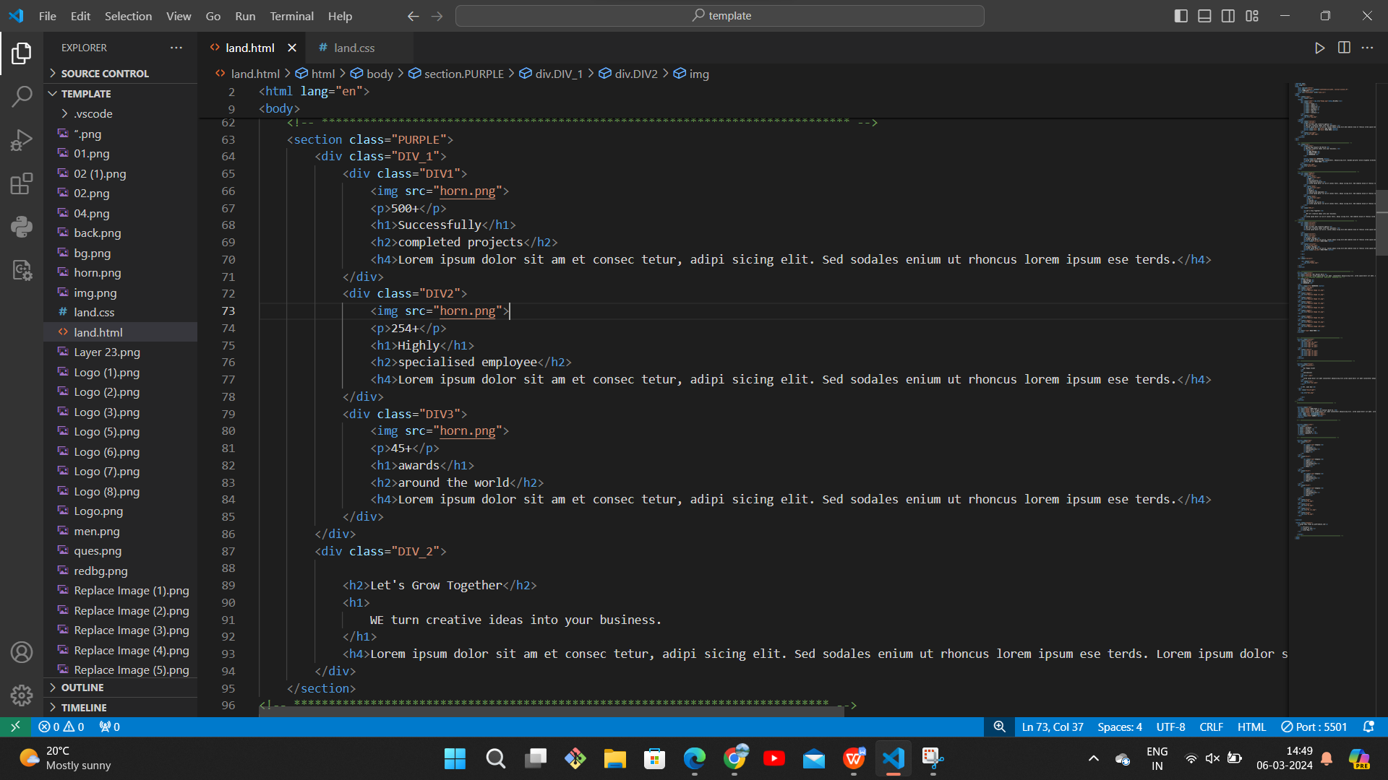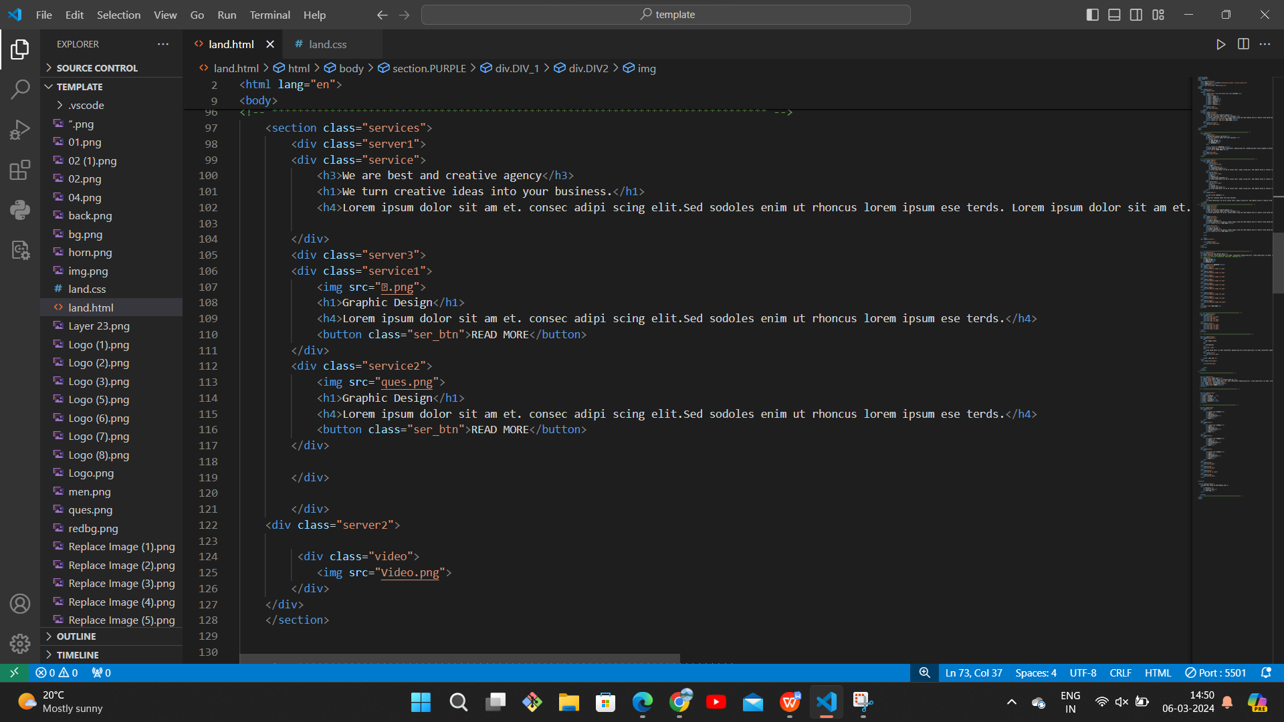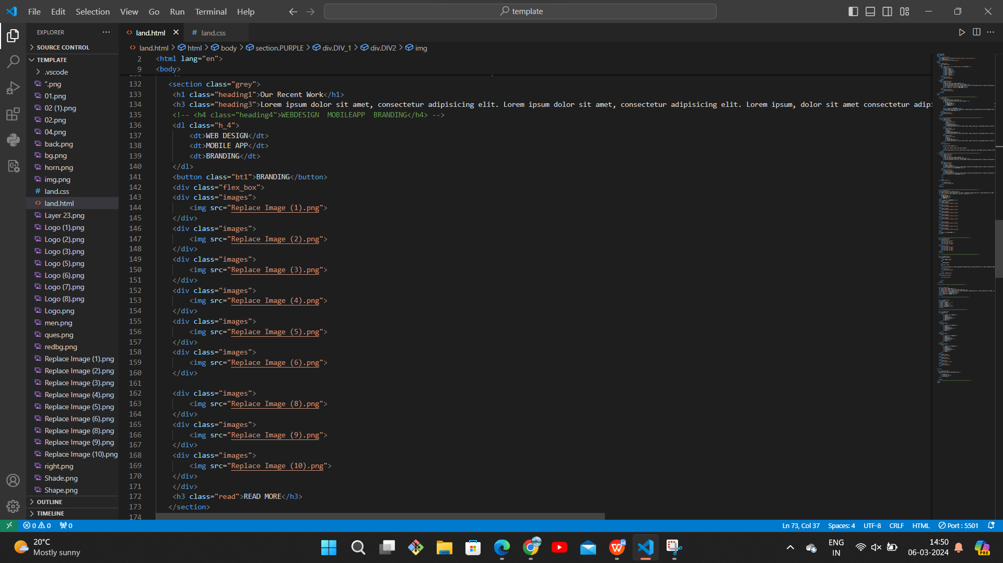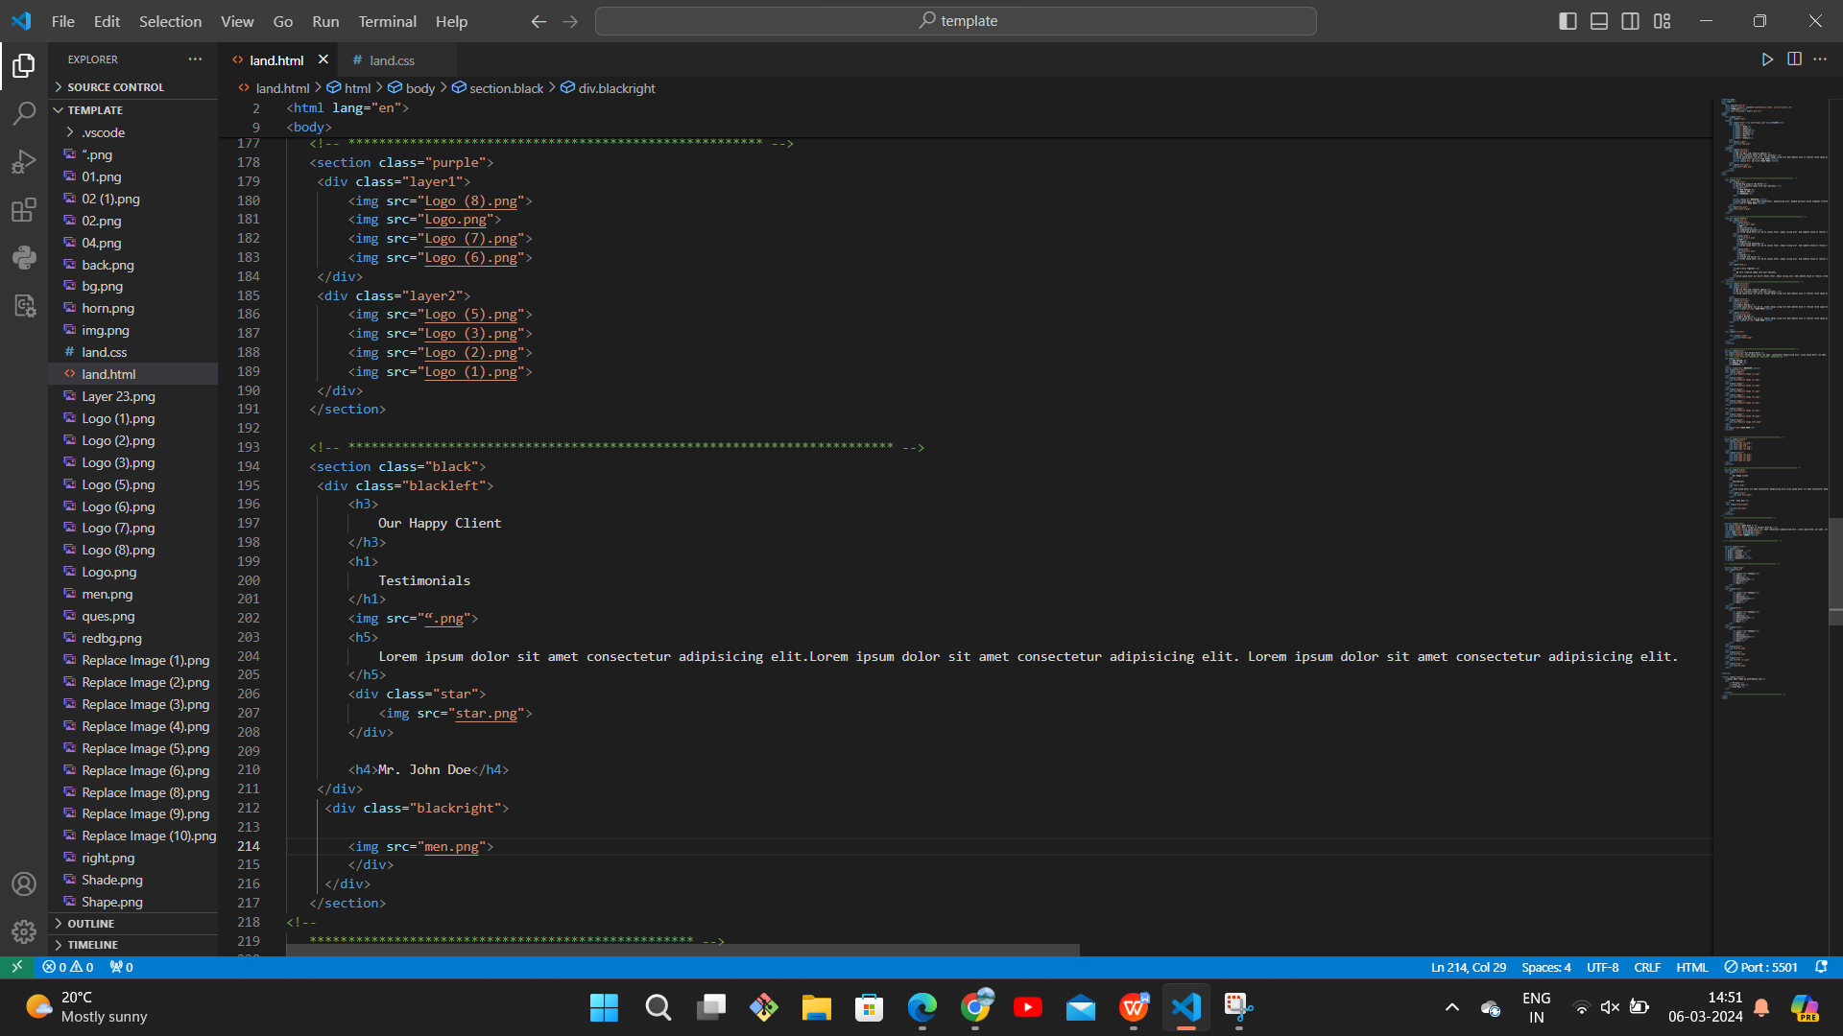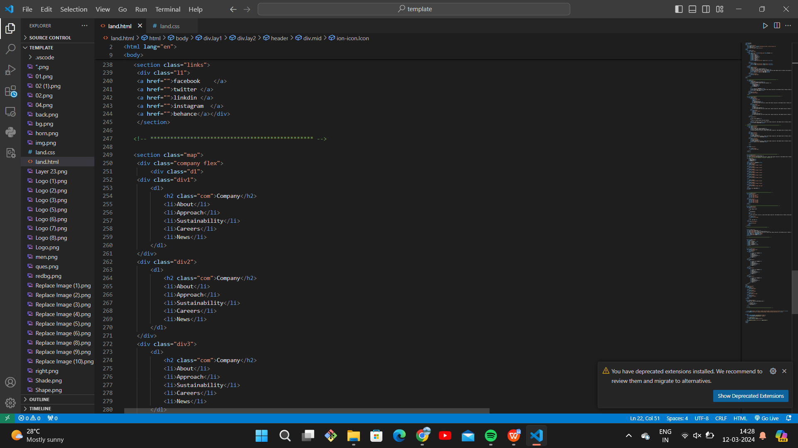

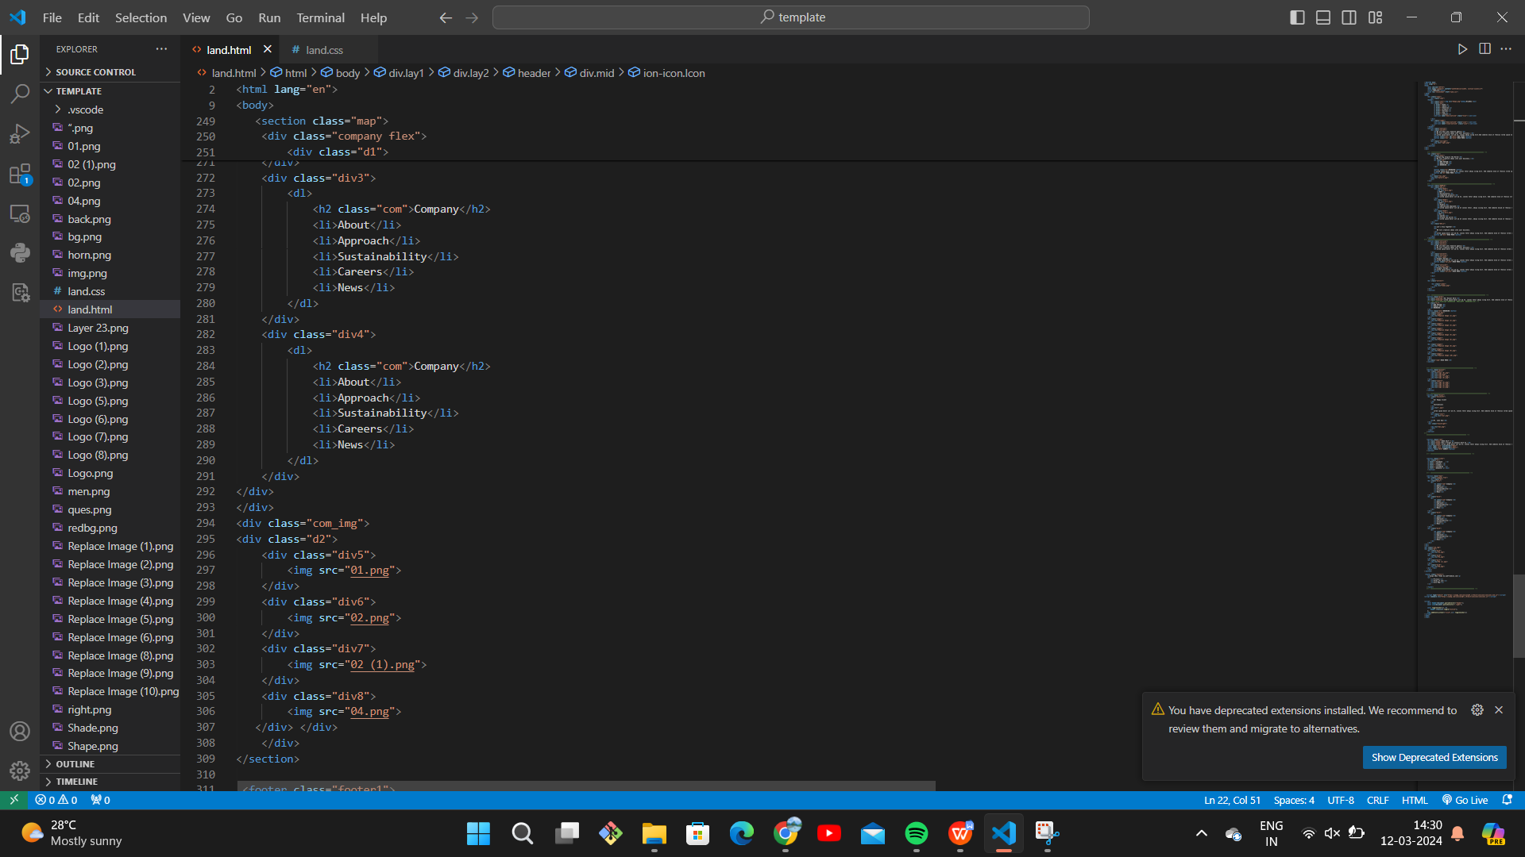

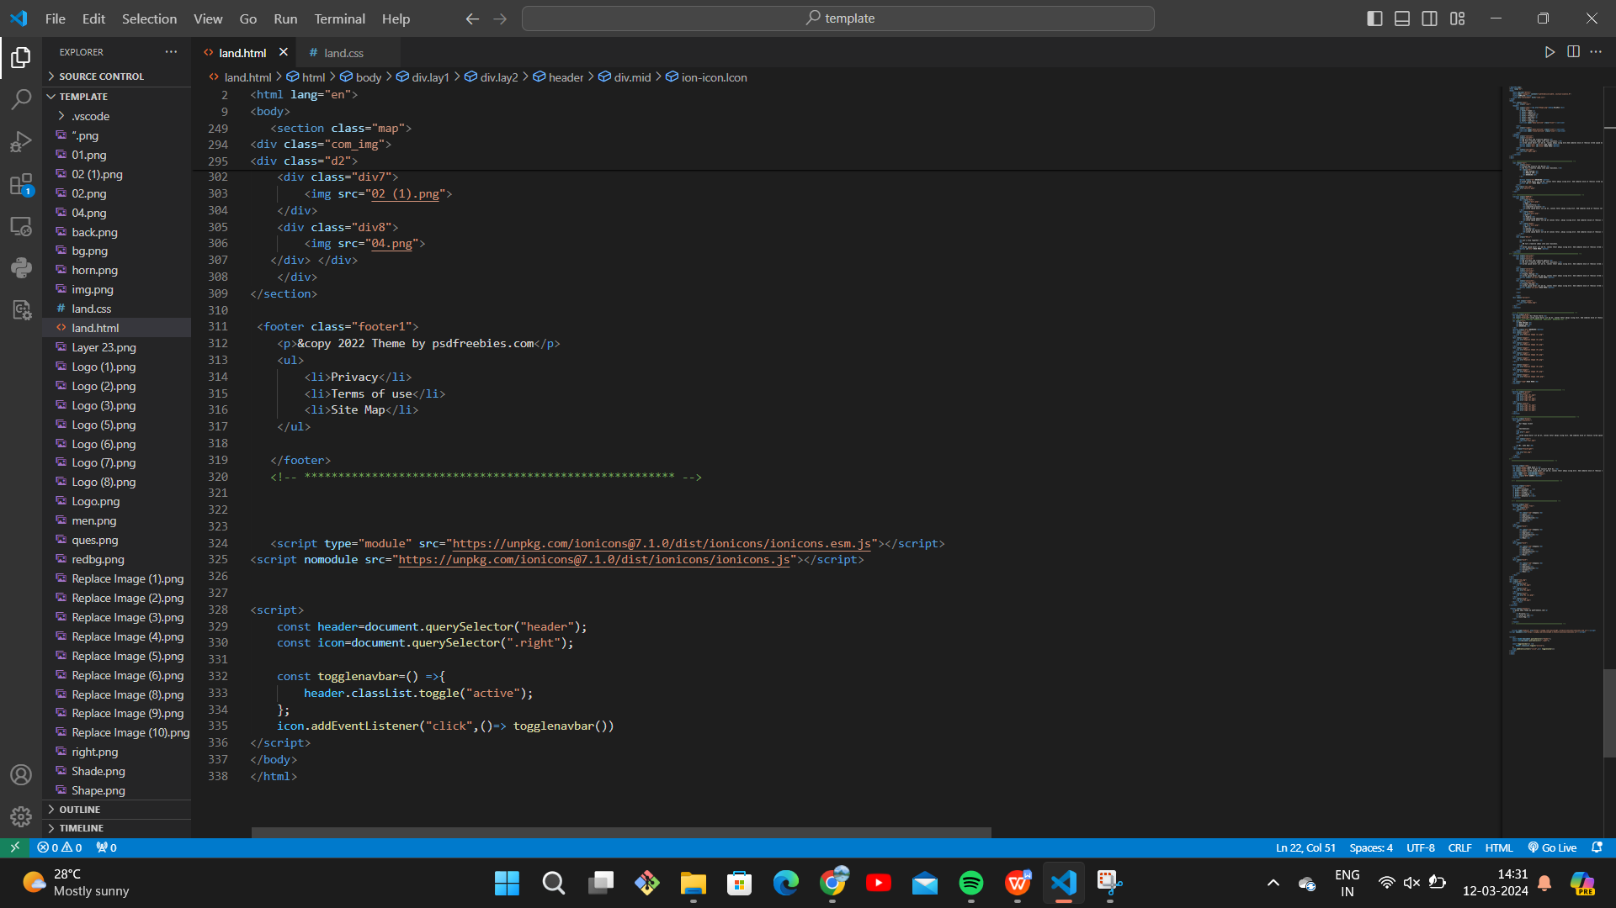

**CSS CODE:**

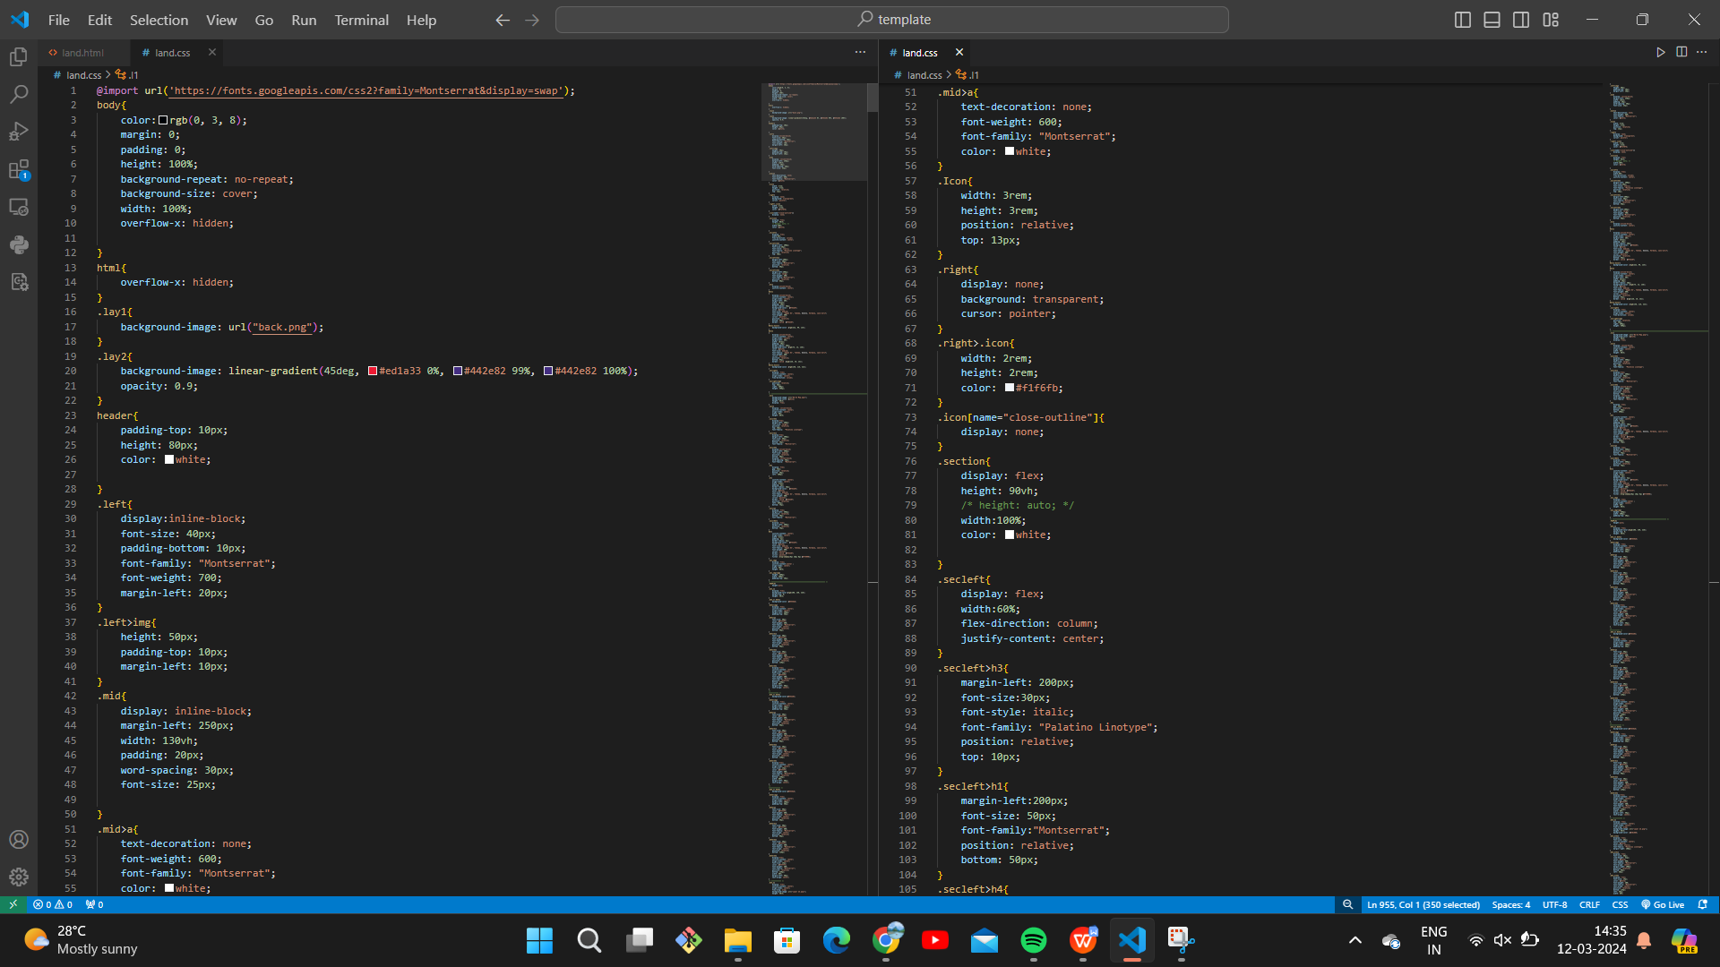

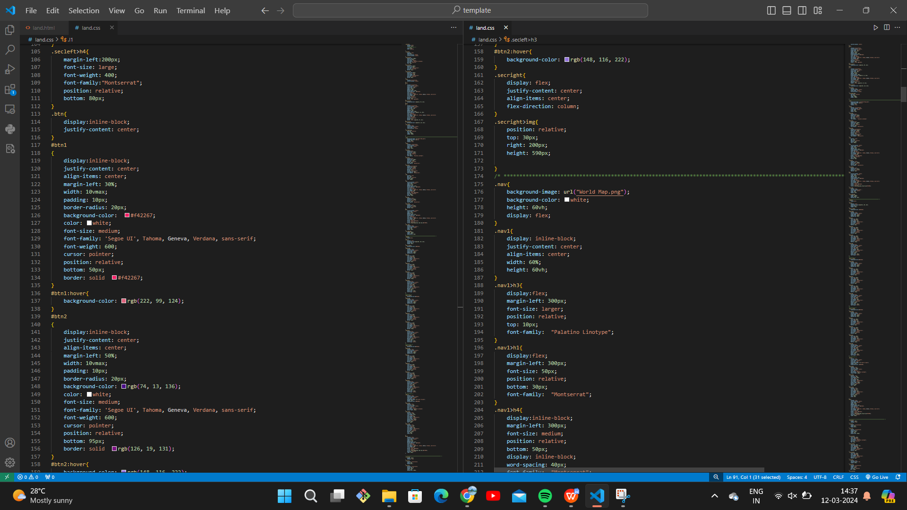

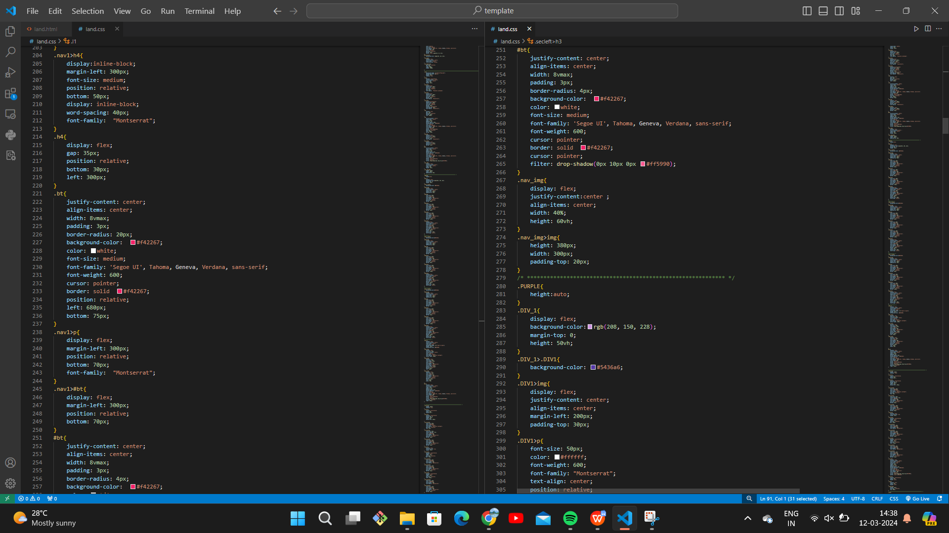

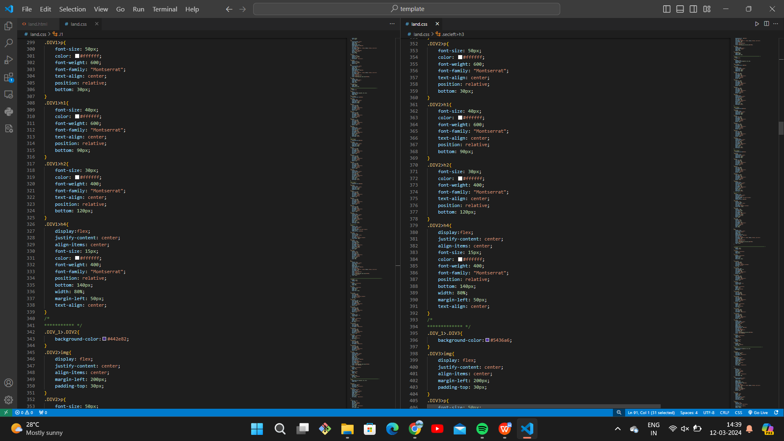

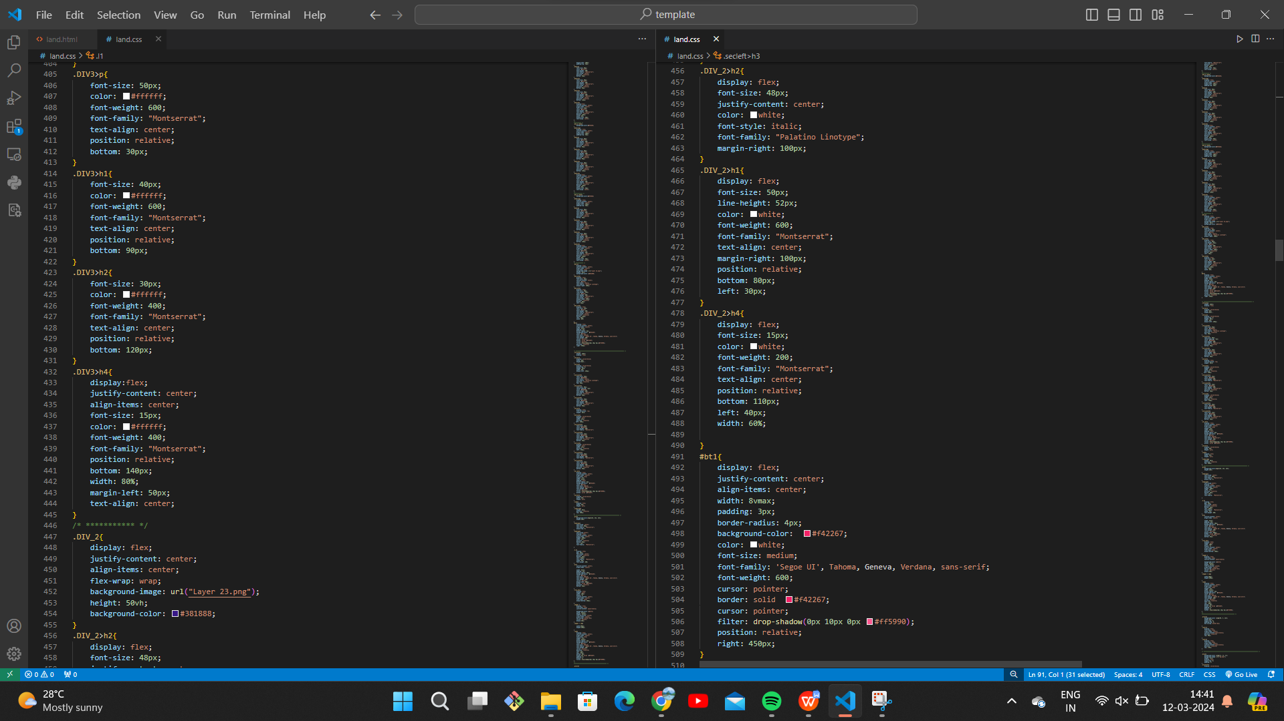

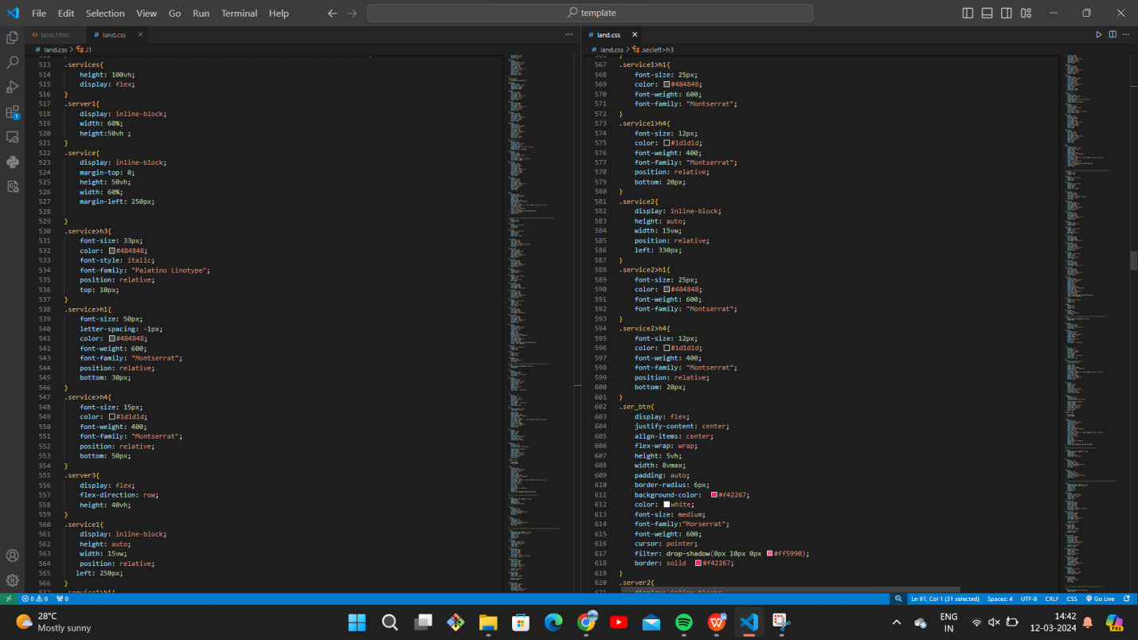

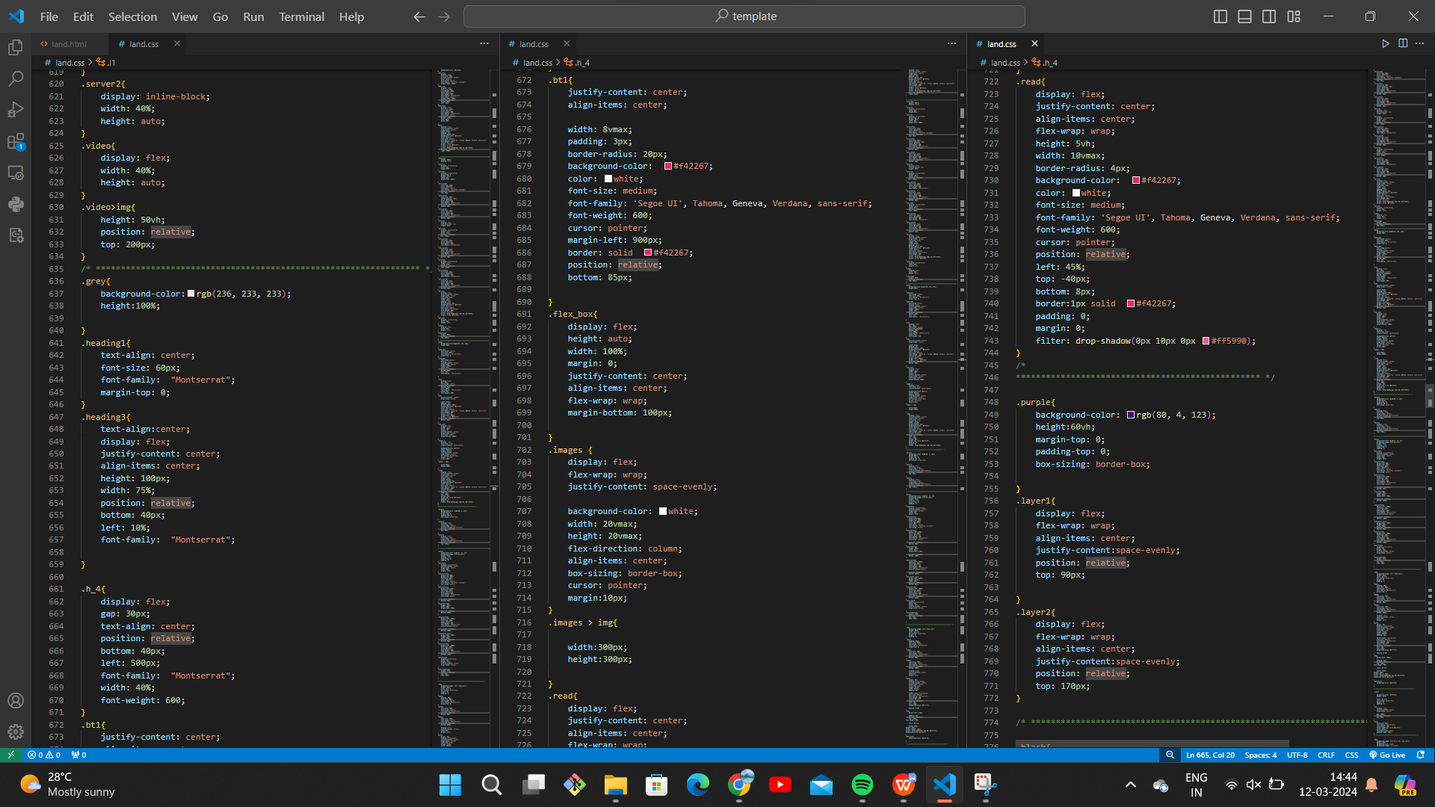

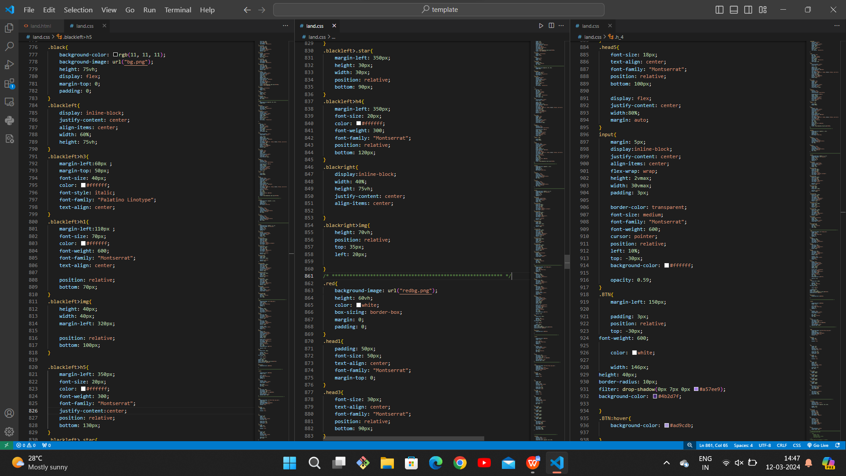

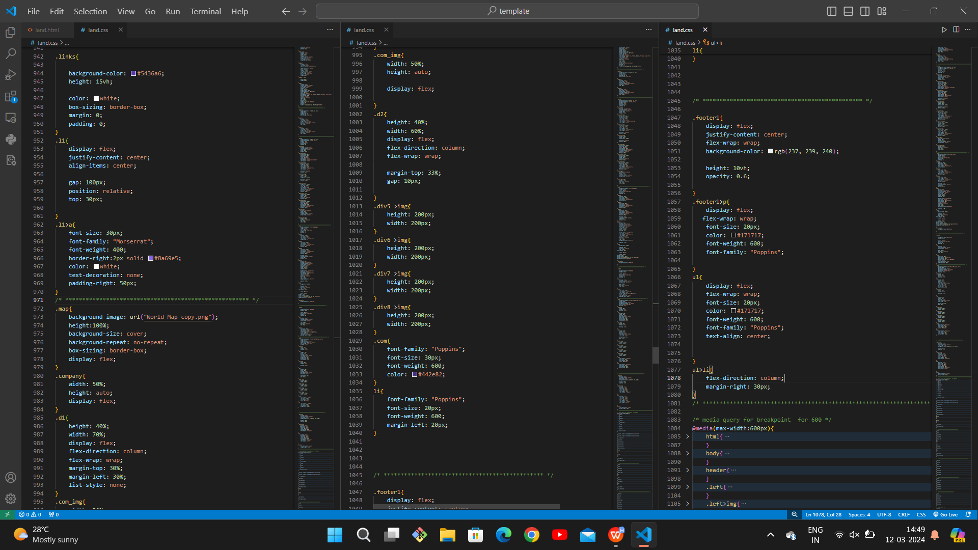

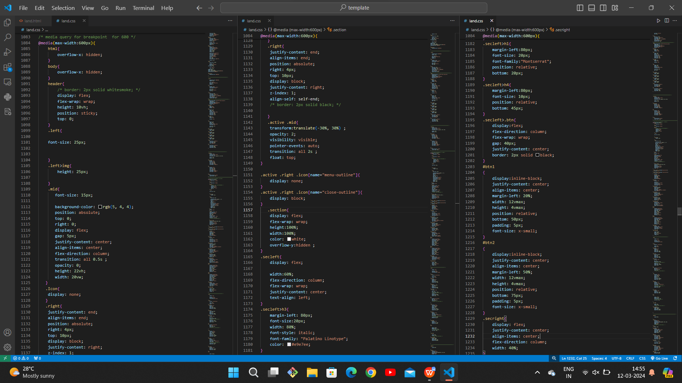

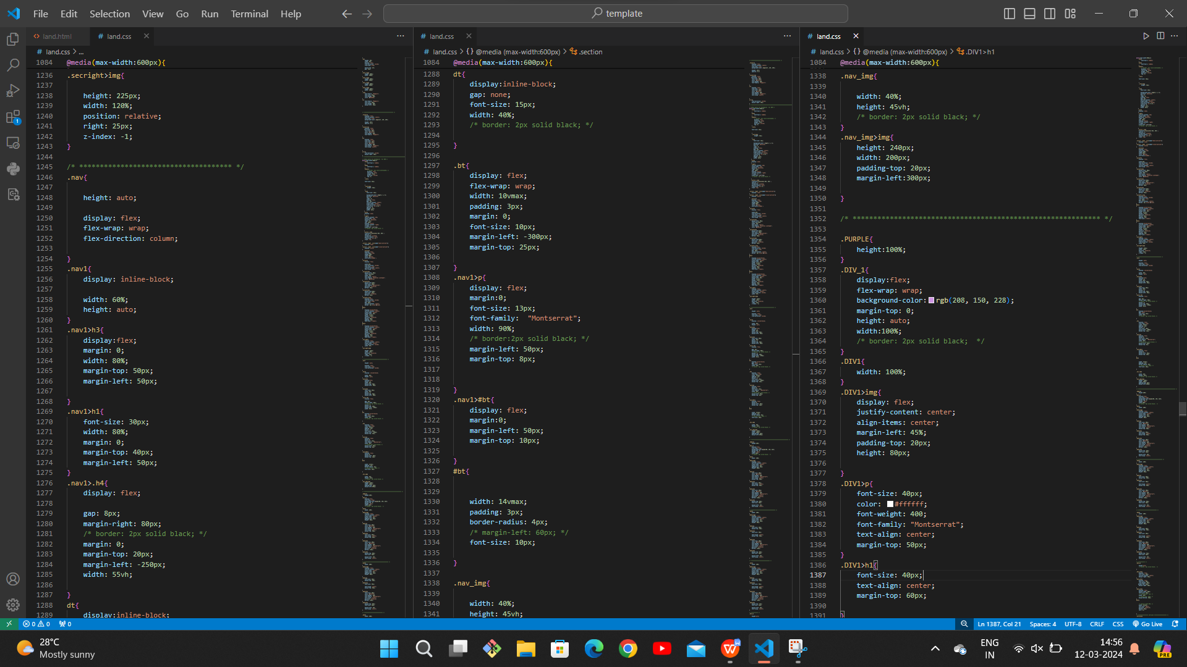

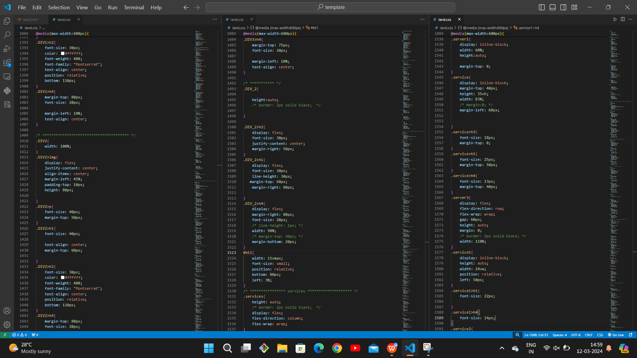

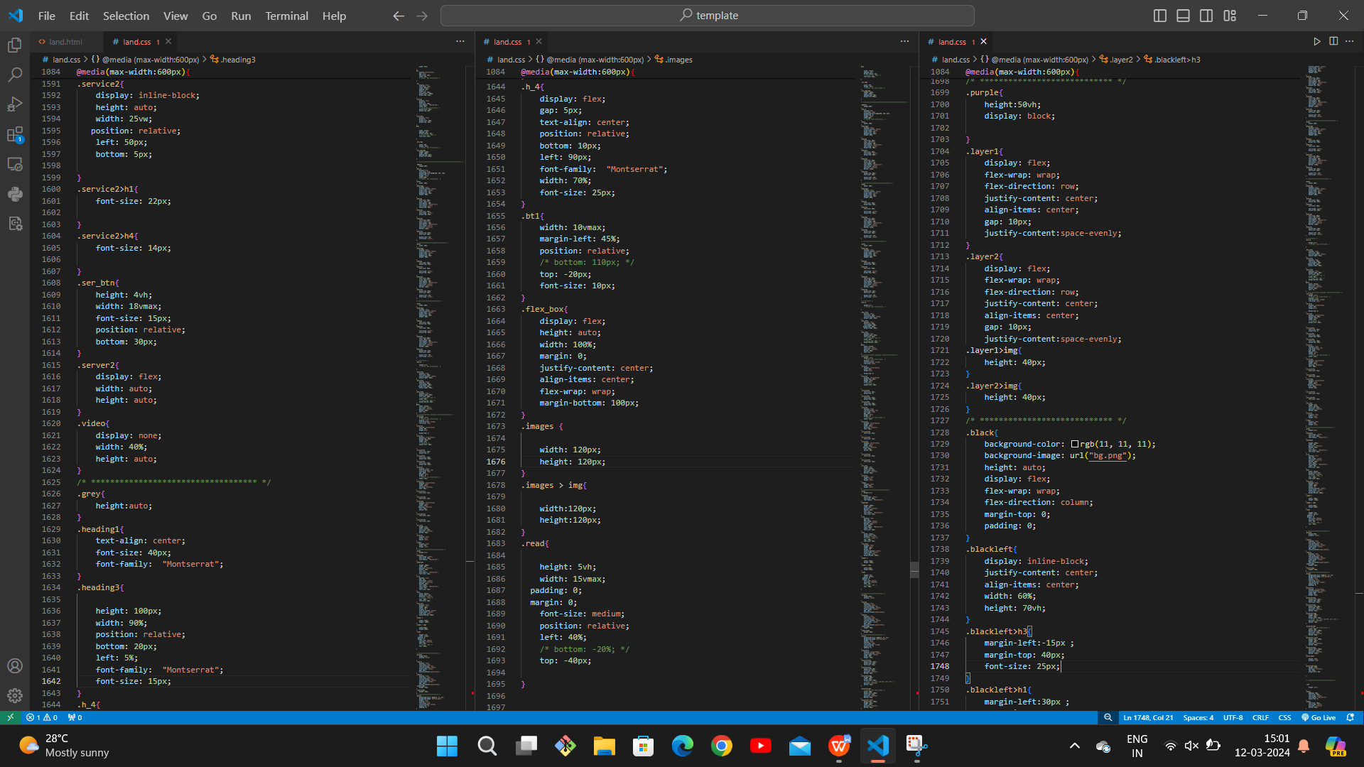

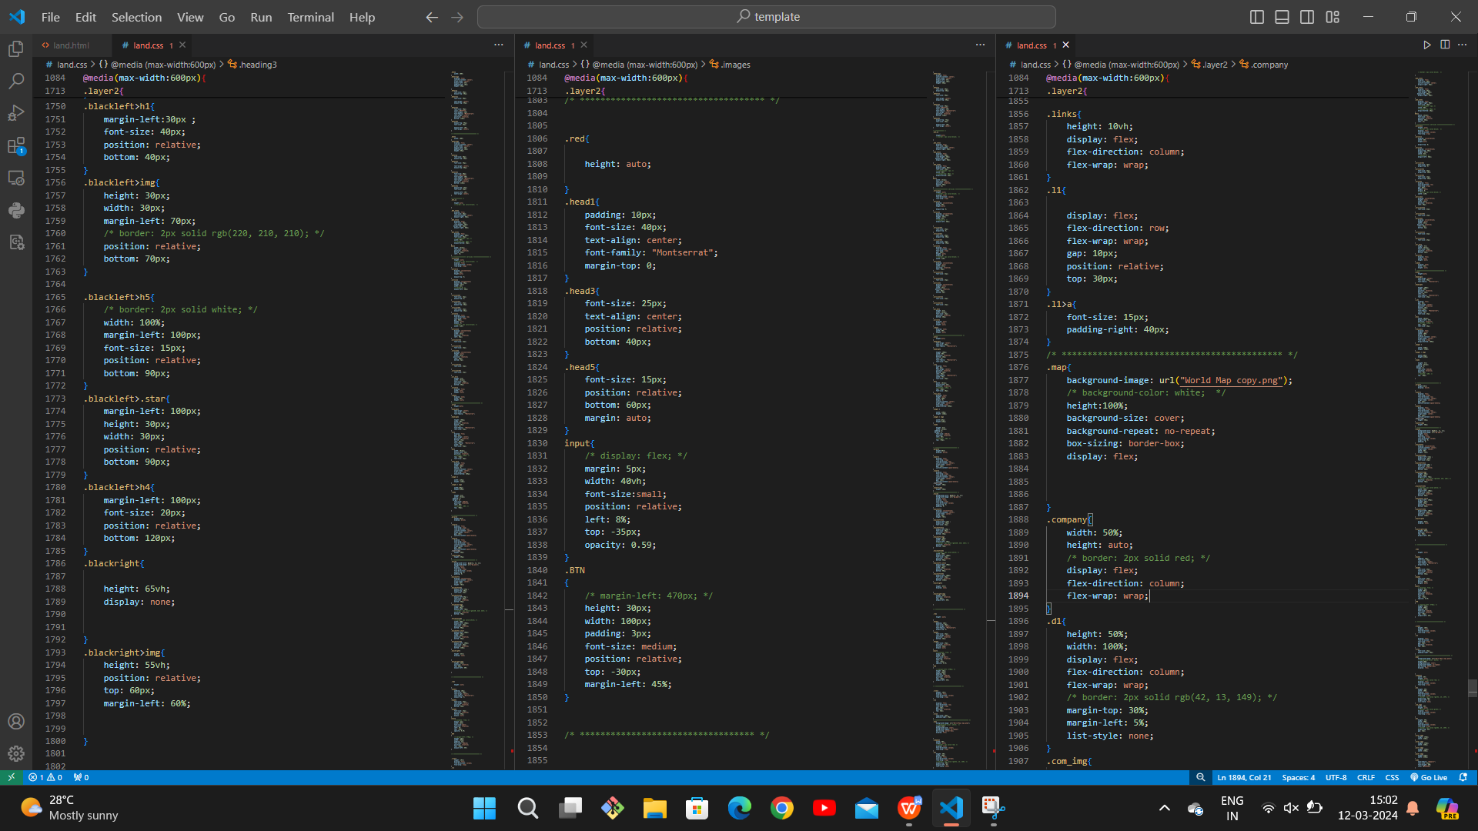

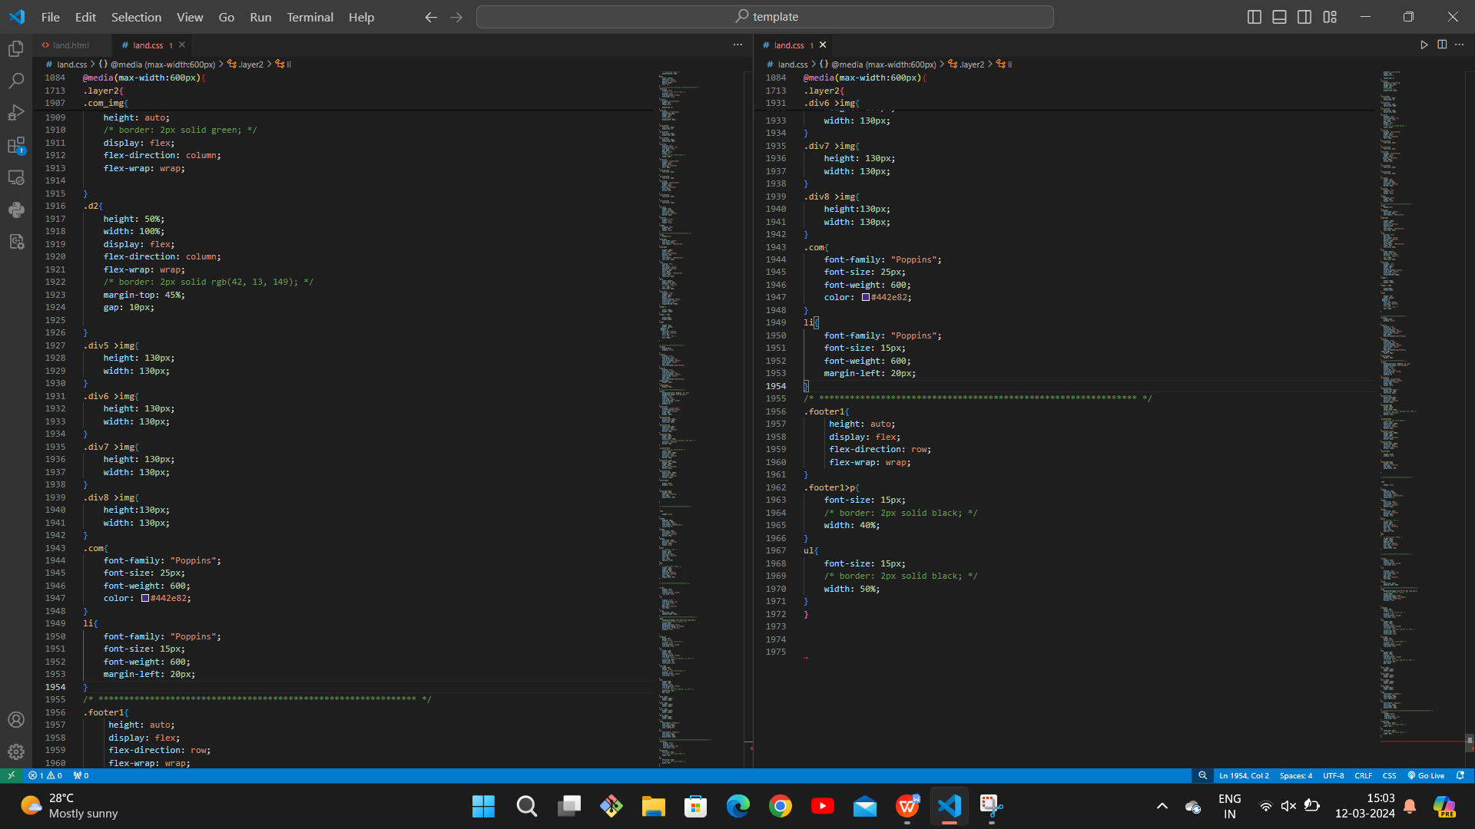

**RESULT:**

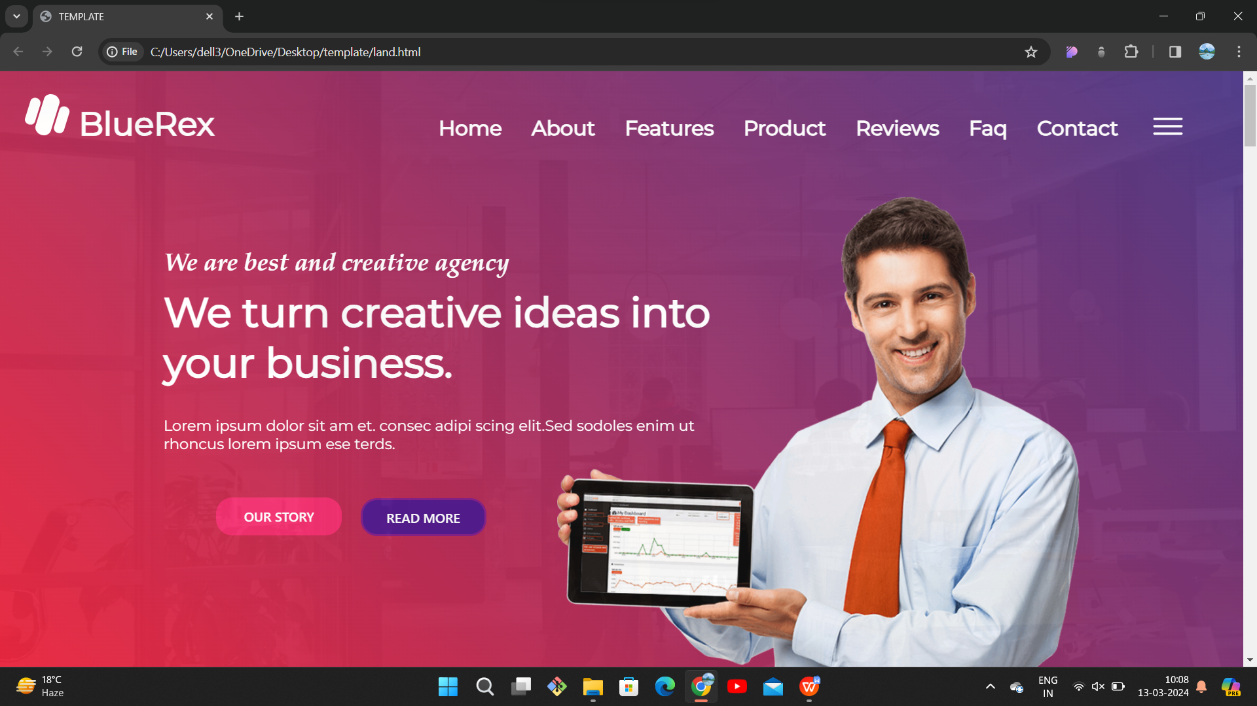

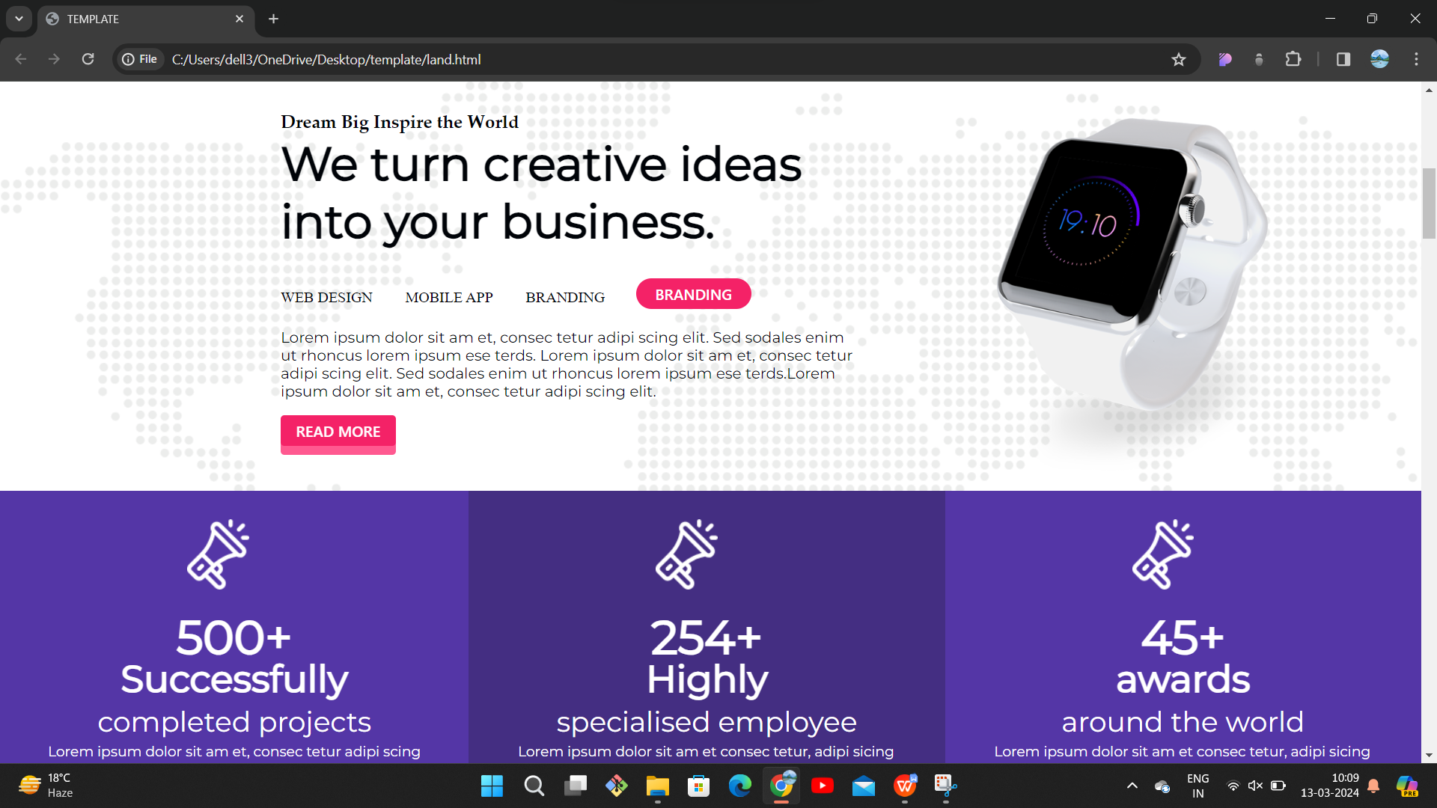

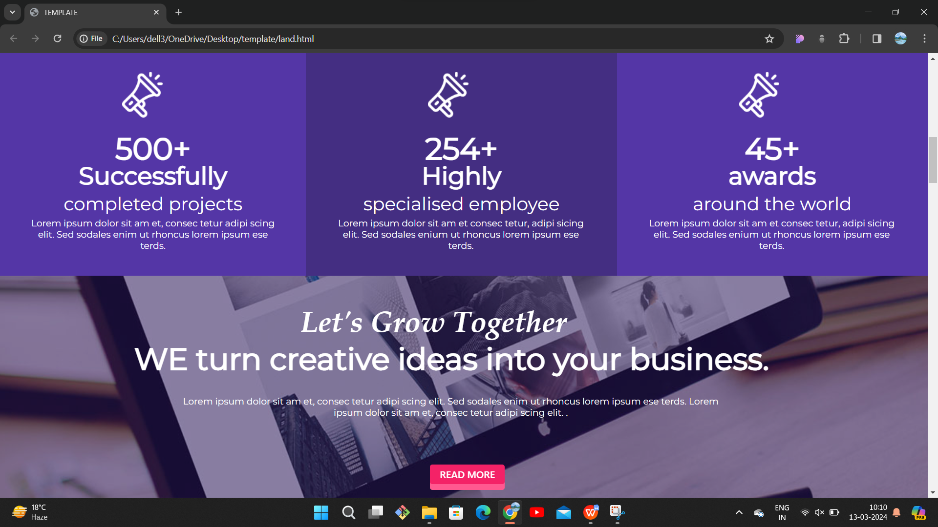

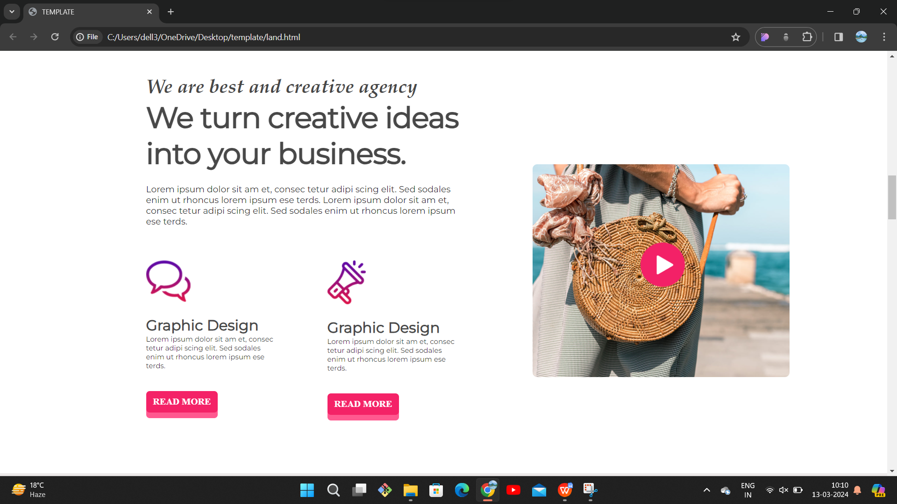

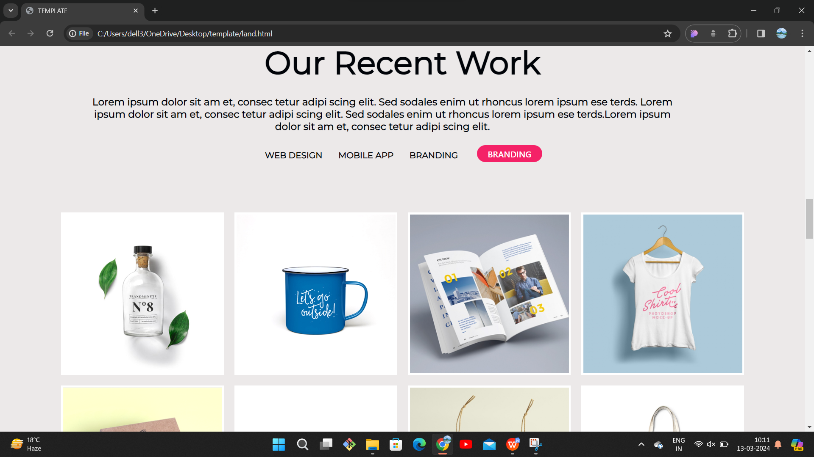

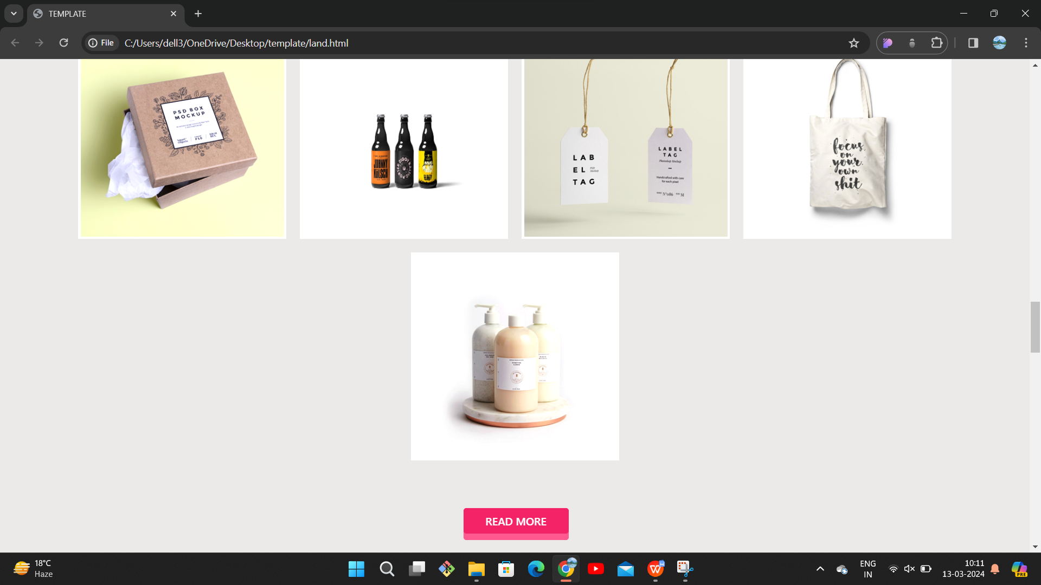

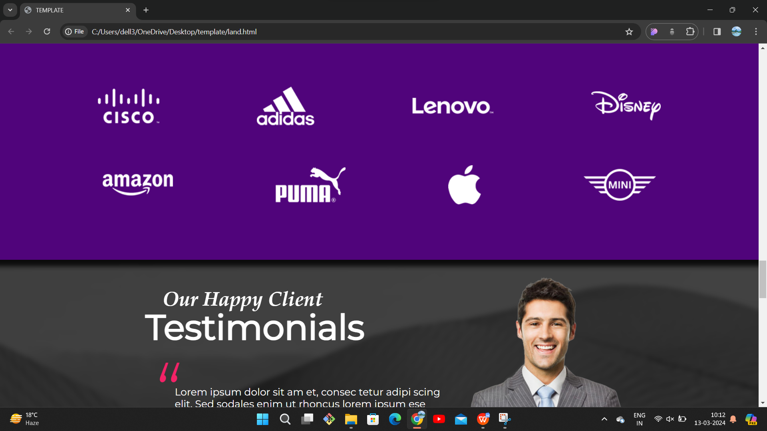

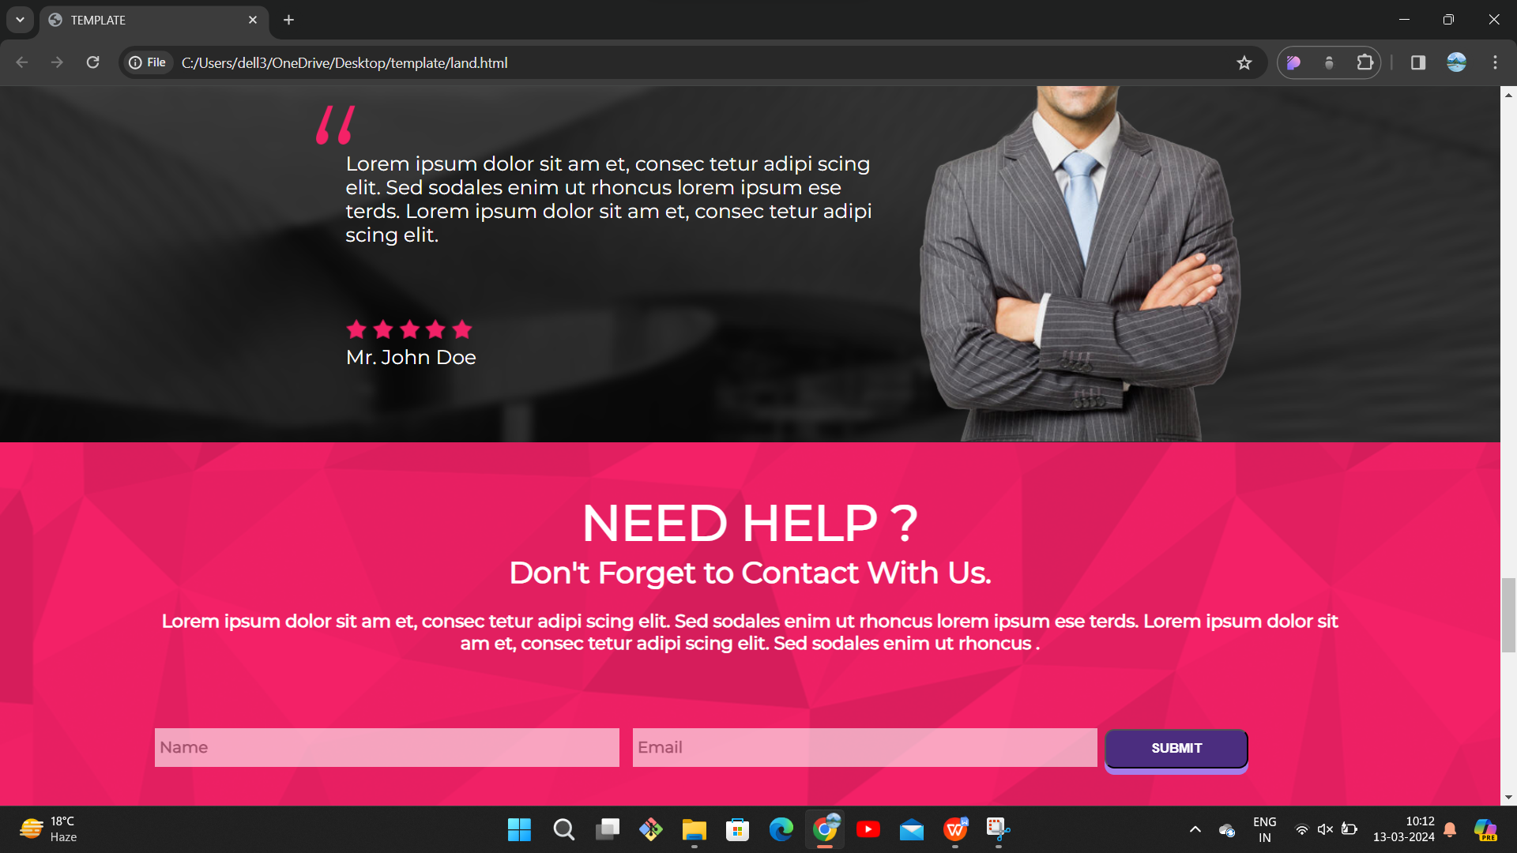

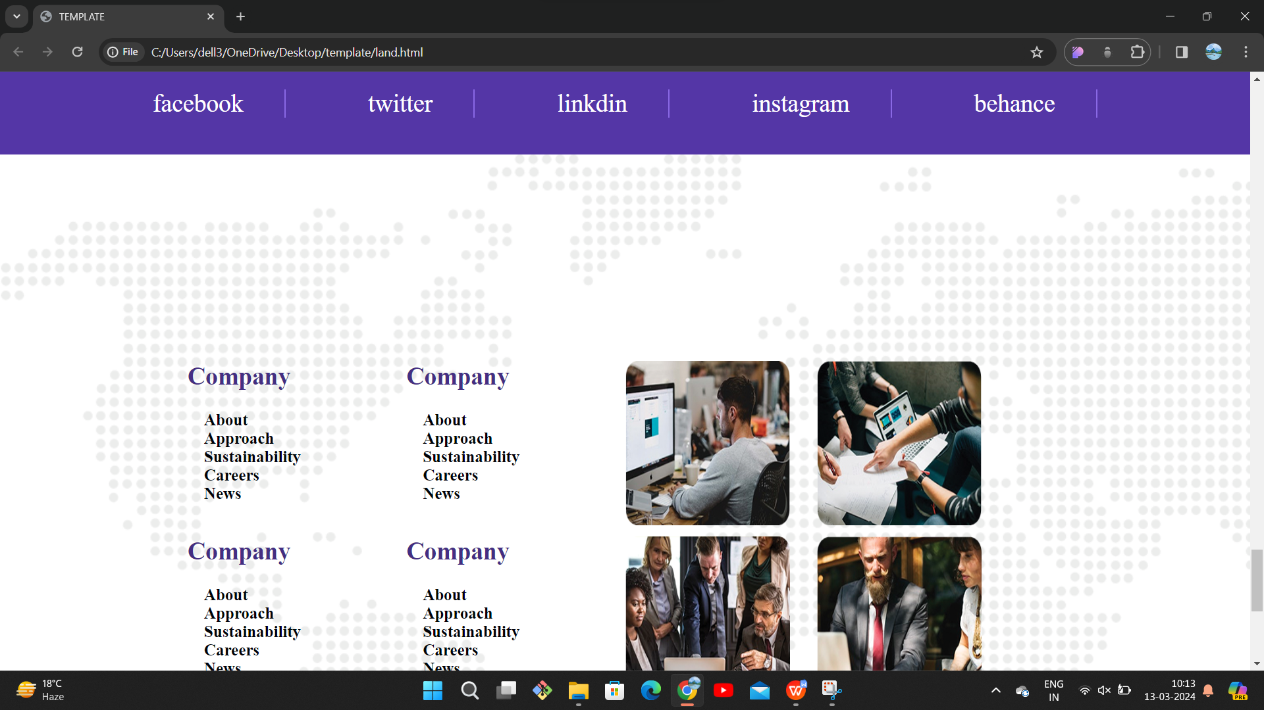

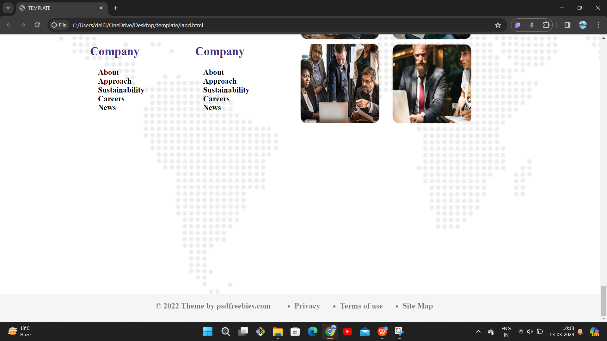

**RESULT ON MEDIA QUERY CODE:**

